Table of Contents
S.no | Title | Population Set
1 | Table 3.4: Demographic and other baseline characteristics [JPMA] | Safety Population 2
2 | Table 3.5.1.1: Summary of <efficacy continuous variables> [JPMA] | Efficacy Analysis Set
3 | Table 3.5.2.1: Summary of <efficacy categorical variables> [JPMA] | Efficacy Analysis Set
4 | Table 3.5.2.2: Subgroup Analyses of <efficacy categorical variables> [JPMA] | Efficacy Analysis Set
5 | Table 3.6: Covariate Analyses of <efficacy continuous variables> [JPMA] | Efficacy Analysis Set
6 | Table 3.11.2: Treatment-Emergent Adverse Events by Severity [JPMA] | Safety Population 2
7 | Table 04: Subject Populations [FDA STF-IG] | Randomized Population
8 | Table 10: Patients With Serious Adverse Events by System Organ Class and Preferred Term [FDA STF-IG] | Safety Population 2
9 | Table 11: Subjects With Serious Adverse Events by Organ System and OCMQ (Narrow) [FDA STF-IG] | Safety Population 2
10 | Table 18: Summary Assessment of [Insert AE of Interest] [FDA STF-IG] | Safety Population 2
11 | Table 33: Subjects With Adverse Events by Male-Specific OCMQ (Narrow) and Preferred Term [FDA STF-IG] | Male Safety Population
12 | Table 34: Subjects With Adverse Events by Female-Specific OCMQ (Narrow) and Preferred Term [FDA STF-IG] | Female Safety Population
13 | Table 45: Subjects With Adverse Events by Female-Specific OCMQ (Broad) and Preferred Term [FDA STF-IG] | Female Safety Population
14 | Figure 14.1.1: Distribution of Race | Safety Population 4
15 | Figure 14.x.y: Bar Chart | Safety Population 3
16 | Figure 14.x.y: Box Plot | Safety Population 3
17 | Figure 14.1.2: Box Plot of Age Distribution | Safety Population 4
18 | Figure 14.1.3: The Effect of Age on Weight by Gender | Safety Population 4
19 | Figure 14.x.y: Line Chart | Safety Population 3
20 | Figure 14.1.4: Distribution of Patients by Age Group and Ethnicity | Safety Population 4
21 | Figure 14.x.y: Stacked Bar Chart | Safety Population 3
22 | Figure 14.2.1.1 [ONC]: Kaplan-Meier Chart for Overall Survival | Efficacy Population
23 | Figure 14.x.y: Kaplan-Meier Chart | Safety Population 3
24 | Figure 14.2.1.2 [ONC]: Kaplan-Meier Chart for Progression Free Survival | Efficacy Population
25 | Figure 14.2.2.1 [ONC]: Swimmer Chart - Patient Disposition and RECIST 1.1 Response | Efficacy Population

EXPORT-STUDY-01

Table 3.4
Demographic and other baseline characteristics [JPMA]
Safety Population 2

 | Treatment A  N=XX | Treatment B  N=XX
Sex
n | XX | XX
<Sex> | XX (XX.X %) | XX (XX.X %)
Age (year)
n | XX | XX
Mean (SD) | XX.X (XX.X) | XX.X (XX.X)
Median | XX.X | XX.X
Min - Max | XX - XX | XX - XX
Age (year)
n | XX | XX
<Age category> | XX (XX.X %) | XX (XX.X %)
Weight (kg)
n | XX | XX
Mean (SD) | XX.X (XX.X) | XX.X (XX.X)
Median | XX.X | XX.X
Min - Max | XX - XX | XX - XX
Weight (kg)
n | XX | XX
<Weight category> | XX (XX.X %) | XX (XX.X %)
Height (cm)
n | XX | XX
Mean (SD) | XX.X (XX.X) | XX.X (XX.X)
Median | XX.X | XX.X
Min - Max | XX - XX | XX - XX
Race
n | XX | XX
<Race> | XX (XX.X %) | XX (XX.X %)

EXPORT-STUDY-01

Table 3.5.1.1
Summary of <efficacy continuous variables> [JPMA]
Efficacy Analysis Set

 | Treatment A  N=XX | Treatment B  N=XX
<Parameter> | XX (XX.X) | XX (XX.X)
<Visit> | XX (XX.X) | XX (XX.X)
n | XX | XX
Mean (SD) | XX.X (XX.X) | XX.X (XX.X)
Median | XX.X | XX.X
Min - Max | XX - XX | XX - XX

EXPORT-STUDY-01

Table 3.5.2.1
Summary of <efficacy categorical variables> [JPMA]
Efficacy Analysis Set

 | Treatment A  N=XX | Treatment B  N=XX
< Parameter >
< Visit >
< Category > | XX (XX.X %) | XX (XX.X %)

EXPORT-STUDY-01

Table 3.5.2.2
Subgroup Analyses of <efficacy categorical variables> [JPMA]
Efficacy Analysis Set

<Category> (N=XX)

 | Treatment A  N=XX | Treatment B  N=XX
< Parameter >
< Visit >
< Category > | XX (XX.X %) | XX (XX.X %)

EXPORT-STUDY-01

Table 3.6
Covariate Analyses of <efficacy continuous variables> [JPMA]
Efficacy Analysis Set

Characteristics | Treatment A  N=XX | Treatment B  N=XX
Parameter
n | XX | XX
LS Mean | XXX.X | XXX.X
Difference vs. Treatment A |  | XXX.X
95% CI for difference |  | XXX.X, XXX.X
p-value |  | X.XXX

EXPORT-STUDY-01

Table 3.11.2
Treatment-Emergent Adverse Events by Severity [JPMA]
Safety Population 2

 | Treatment A (N=XX)
 | Any  n (%) | Mild  n (%) | Moderate  n (%) | Severe  n (%)
Number of subjects reporting at least one TEAE | XX (XX.X) | XX (XX.X) | XX (XX.X) | XX (XX.X)
System Organ Class X | XX (XX.X) | XX (XX.X) | XX (XX.X) | XX (XX.X)
Preferred Term X | XX (XX.X) | XX (XX.X) | XX (XX.X) | XX (XX.X)

TEAE: Treatment emergent adverse events

EXPORT-STUDY-01

Table 04
Subject Populations [FDA STF-IG]
Randomized Population
Pooled Analysis (or Trial X)

Population | Drug Name  Dosage A  N = XXX  n (%) | Control  N = XXX  n (%)
Subjects randomized | X (Y) | X (Y)
ITT population | X (Y) | X (Y)
mITT population | X (Y) | X (Y)
Safety population | X (Y) | X (Y)
Per-protocol population | X (Y) | X (Y)

Abbreviations: ITT, intent-to-treat; mITT, modified intent-to-treat; n, number of subjects in specified subset of the treatment arm; N, number of subjects in treatment arm.
Source: [include Applicant source, datasets and/or software tools used].
Note: Duration = [e.g., X-week double-blind treatment period or median and a range of pooled trial durations].

EXPORT-STUDY-01

Table 10
Patients With Serious Adverse Events by System Organ Class and Preferred Term [FDA STF-IG]
Safety Population 2
Pooled Analyses (or Trial X)

System Organ Class  Preferred Term | Drug Name  Dosage A  N = XXX  n (%) | Control  N = XXX  n (%) | Risk Difference  % (95% CI) ¹
Any SAE | X (Y) | X (Y) | X (Y, Z)
SOC X | X (Y) | X (Y) | X (Y, Z)
PT X | X (Y) | X (Y) | X (Y, Z)

Abbreviations: CI, confidence interval; n, number of subjects with adverse event; N, number of subjects in treatment arm; PT, preferred term; SAE, serious adverse event; SOC, system organ class.
Source: [include Applicant source, datasets and/or software tools used].
Note: SAEs classified by Applicant as [insert Applicant’s definition of SAE].
Note: Duration = [e.g., X-week double-blind treatment period or median and a range of pooled trial durations].
¹ Risk difference is shown between [treatment arms] (e.g., difference is shown between Drug Name Dosage A vs. Control).

EXPORT-STUDY-01

Table 11
Subjects With Serious Adverse Events by Organ System and OCMQ (Narrow) [FDA STF-IG]
Safety Population 2
Pooled Analysis (or Trial X)

Organ System¹  OCMQ (Narrow) | Drug Name  Dosage A  N = XXX  n (%) | Control  N = XXX  n (%) | Risk Difference  % (95% CI) ²
Organ System X |  |  | X (Y, Z)
OCMQ X | X (Y) | X (Y) | X (Y, Z)

Abbreviations: CI, confidence interval; OCMQ, OND custom medical query; MedDRA, Medical Dictionary for Regulatory Activities; n, number of subjects with adverse event; N, number of subjects in treatment arm; PT, preferred term; SAE, serious adverse event; SOC, system organ class.
Source: [include Applicant source, datasets and/or software tools used].
Note: SAEs classified by Applicant as [insert Applicant’s definition of SAE].
Note: Duration = [e.g., X-week double-blind treatment period or median and a range of pooled trial durations].
1 Each OCMQ is aligned to a single organ system based on clinical judgment. Please be aware that some OCMQs may contain PTs from more than one MedDRA SOC.
2 Risk difference is shown between [treatment arms] (e.g., difference is shown between Drug Name Dosage A vs. Control).

EXPORT-STUDY-01

Table 18
Summary Assessment of [Insert AE of Interest] [FDA STF-IG]
Safety Population 2
Pooled Analysis (or Trial X)

AE of Interest Assessment | Drug Name  Dosage A  N = XXX  n (%) | Control  N = XXX  n (%) | Risk Difference  % (95% CI) ¹
[Insert AE of Interest] ² | X (Y) | X (Y) | X (Y, Z)
PT X | X (Y) | X (Y) | X (Y, Z)
Maximum severity ³ | X (Y) | X (Y) | X (Y, Z)
Severity X | X (Y) | X (Y) | X (Y, Z)
SAE ⁴ | X (Y) | X (Y) | X (Y, Z)
Death | X (Y) | X (Y) | X (Y, Z)
Life-threatening | X (Y) | X (Y) | X (Y, Z)
Initial or prolonged hospitalization | X (Y) | X (Y) | X (Y, Z)
Disability or permanent damage | X (Y) | X (Y) | X (Y, Z)
Congenital anomaly or birth defect | X (Y) | X (Y) | X (Y, Z)
Other | X (Y) | X (Y) | X (Y, Z)
Resulting in treatment discontinuation | X (Y) | X (Y) | X (Y, Z)

Abbreviations: AE, adverse event; AESI, adverse event of special interest; CI, confidence interval; OCMQ, OND custom medical query; n, number of subjects with at least one event; N, number of subjects in treatment arm; PT, preferred term; SAE, serious adverse event.
Source: [include Applicant source, datasets and/or software tools used].
Note: Duration = [e.g., X-week double-blind treatment period or median and a range of pooled trial durations].
¹ Risk difference is shown between [treatment arms] (e.g., difference is shown between Drug Name Dosage A vs. Control).
² Use OCMQ grouping if appropriate.
³ Severity scale as defined by the protocol.
⁴ SAEs classified by Applicant as [insert Applicant’s definition of SAE].

EXPORT-STUDY-01

Table 33
Subjects With Adverse Events by Male-Specific OCMQ (Narrow) and Preferred Term [FDA STF-IG]
Male Safety Population
Pooled Analysis (or Trial X)

OCMQ (Narrow)  Preferred Term ¹ | Drug Name  Dosage A  N = XXX  n/Nₛ (%) | Control  N = XXX  n/Nₛ (%) | Risk Difference  % (95% CI) ²
Erectile Dysfunction | X/Y (Z) | X/Y (Z) | X (Y, Z)
PT X | X/Y (Z) | X/Y (Z) | X (Y, Z)
Gynecomastia | X/Y (Z) | X/Y (Z) | X (Y, Z)
PT X | X/Y (Z) | X/Y (Z) | X (Y, Z)

Abbreviations: AE, adverse event; CI, confidence interval; OCMQ, OND custom medical query; MedDRA, Medical Dictionary for Regulatory Activities; n, number of male subjects with indicated OCMQ; N, number of subjects in treatment arm; Ns, number of male subjects with adverse event data.
Source: [include Applicant source, datasets and/or software tools used].
Note: Treatment-emergent AE defined as [definition]. MedDRA version X.
Note: Duration = [e.g., X-week double-blind treatment period or median and a range of pooled trial durations].
¹ OCMQs include AEs that are not MedDRA PTs.
² Risk Difference is shown between [treatment arms] (e.g., difference is shown between Drug Name Dosage A vs. Control).

EXPORT-STUDY-01

Table 34
Subjects With Adverse Events by Female-Specific OCMQ (Narrow) and Preferred Term [FDA STF-IG]
Female Safety Population
Pooled Analyses (or Trial X)

OCMQ (Narrow)  Preferred Term ¹ | Drug Name  Dosage A  N = XXX  n/Nₛ (%) | Control  N = XXX  n/Nₛ (%) | Risk Difference  % (95% CI) ²
Abnormal uterine bleeding | X/Y (Z) | X/Y (Z) | X (Y, Z)
PT X | X/Y (Z) | X/Y (Z) | X (Y, Z)
Amenorrhea | X/Y (Z) | X/Y (Z) | X (Y, Z)
PT X | X/Y (Z) | X/Y (Z) | X (Y, Z)
Bacterial vaginosis | X/Y (Z) | X/Y (Z) | X (Y, Z)
PT X | X/Y (Z) | X/Y (Z) | X (Y, Z)
Decreased menstrual bleeding | X/Y (Z) | X/Y (Z) | X (Y, Z)
PT X | X/Y (Z) | X/Y (Z) | X (Y, Z)
Excessive menstrual bleeding | X/Y (Z) | X/Y (Z) | X (Y, Z)
PT X | X/Y (Z) | X/Y (Z) | X (Y, Z)

Abbreviations: AE, adverse event; CI, confidence interval; OCMQ, OND custom medical query; MedDRA, Medical Dictionary for Regulatory Activities; n, number of female subjects with indicated OCMQ; N, number of subjects in treatment arm; Ns, number of female subjects with adverse event data.
Source: [include Applicant source, datasets and/or software tools used].
Note: Treatment-emergent AE defined as [definition]. MedDRA version X.
Note: Duration = [e.g., X-week double-blind treatment period or median and a range of pooled trial durations].
¹ OCMQs include AEs that are not MedDRA PTs.
² Risk difference is shown between [treatment arms] (e.g., difference is shown between Drug Name Dosage A vs. Control).

EXPORT-STUDY-01

Table 45
Subjects With Adverse Events by Female-Specific OCMQ (Broad) and Preferred Term [FDA STF-IG]
Female Safety Population
Pooled Analyses (or Trial X)

OCMQ (Narrow)  Preferred Term ¹ | Drug Name  Dosage A  N = XXX  n/Nₛ (%) | Control  N = XXX  n/Nₛ (%) | Risk Difference  % (95% CI) ²,³
Abnormal uterine bleeding | X/Y (Z) | X/Y (Z) | X (Y, Z)
PT X | X/Y (Z) | X/Y (Z) | X (Y, Z)
Amenorrhea | X/Y (Z) | X/Y (Z) | X (Y, Z)
PT X | X/Y (Z) | X/Y (Z) | X (Y, Z)
Bacterial vaginosis | X/Y (Z) | X/Y (Z) | X (Y, Z)
PT X | X/Y (Z) | X/Y (Z) | X (Y, Z)
Decreased menstrual bleeding | X/Y (Z) | X/Y (Z) | X (Y, Z)
PT X | X/Y (Z) | X/Y (Z) | X (Y, Z)
Excessive menstrual bleeding | X/Y (Z) | X/Y (Z) | X (Y, Z)
PT X | X/Y (Z) | X/Y (Z) | X (Y, Z)

Abbreviations: AE, adverse event; CI, confidence interval; OCMQ, OND custom medical query; MedDRA, Medical Dictionary for Regulatory Activities; n, number of female subjects with indicated OCMQ; N, number of subjects in treatment arm; Ns, number of female subjects with adverse event data.
Source: [include Applicant source, datasets and/or software tools used].
Note: Treatment-emergent AE defined as [definition]. MedDRA version X.
Note: Broad OCMQ analysis incorporates narrow OCMQ preferred terms to maximize sensitivity.
Note: Duration = [e.g., X-week double-blind treatment period or median and a range of pooled trial durations].
¹ OCMQs include AEs that are not MedDRA PTs.
² Risk difference is shown between [treatment arms] (e.g., difference is shown between Drug Name Dosage A vs. Control).
³ Table displays categories by risk difference.

EXPORT-STUDY-01

Figure 14.1.1
Distribution of Race
Safety Population 4

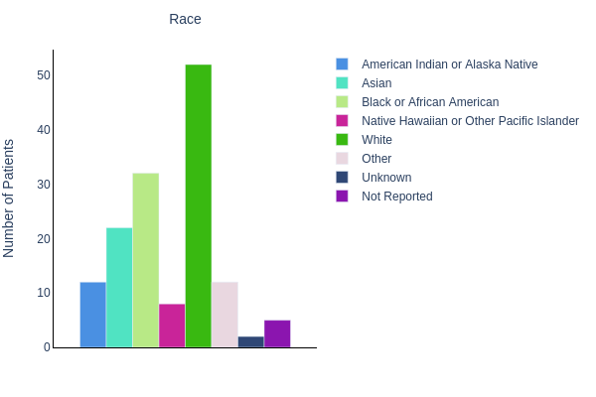
Source: adxx; Program name; Program run date/time

EXPORT-STUDY-01

Figure 14.x.y
Bar Chart
Safety Population 3

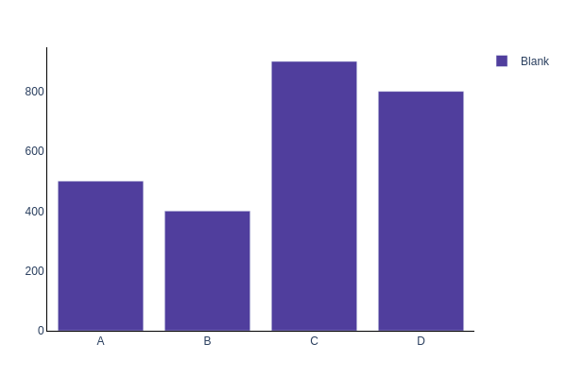

EXPORT-STUDY-01

Figure 14.x.y
Box Plot
Safety Population 3

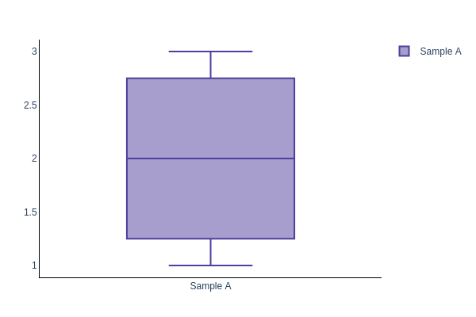

EXPORT-STUDY-01

Figure 14.1.2
Box Plot of Age Distribution
Safety Population 4

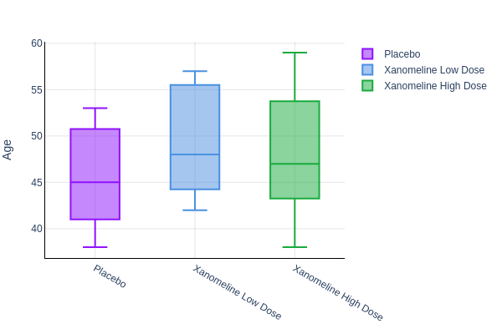
Source: adxx; Program name; Program run date/time

EXPORT-STUDY-01

Figure 14.1.3
The Effect of Age on Weight by Gender
Safety Population 4

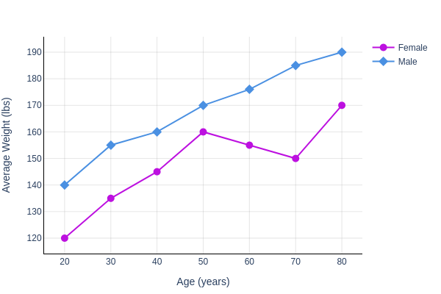
Source: adxx; Program name; Program run date/time

EXPORT-STUDY-01

Figure 14.x.y
Line Chart
Safety Population 3

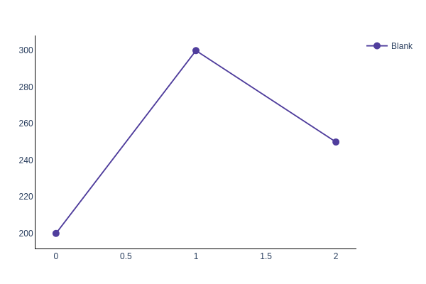

EXPORT-STUDY-01

Figure 14.1.4
Distribution of Patients by Age Group and Ethnicity
Safety Population 4

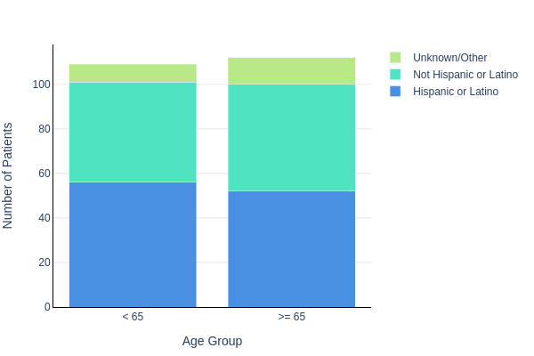
Source: adxx; Program name; Program run date/time

EXPORT-STUDY-01

Figure 14.x.y
Stacked Bar Chart
Safety Population 3

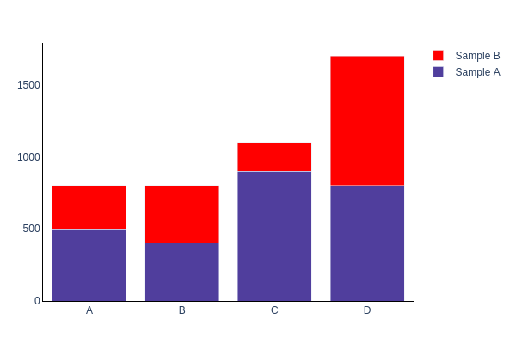

EXPORT-STUDY-01

Figure 14.2.1.1 [ONC]
Kaplan-Meier Chart for Overall Survival
Efficacy Population

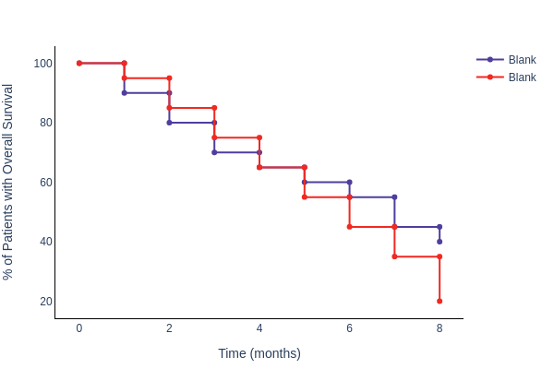

EXPORT-STUDY-01

Figure 14.x.y
Kaplan-Meier Chart
Safety Population 3

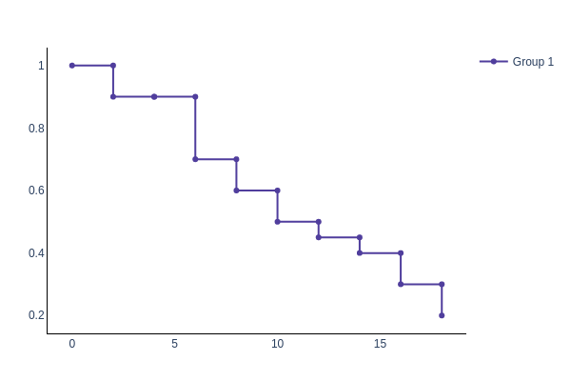

EXPORT-STUDY-01

Figure 14.2.1.2 [ONC]
Kaplan-Meier Chart for Progression Free Survival
Efficacy Population

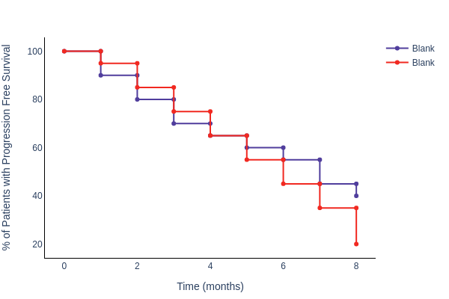

EXPORT-STUDY-01

Figure 14.2.2.1 [ONC]
Swimmer Chart - Patient Disposition and RECIST 1.1 Response
Efficacy Population

